

NAME: ABDUL SAMI Wadho

SIR NAME: SIR AFTAB ALI CHANDIO

ROLL NO : 2K20/CSE/8

INSTITUTE OF MATHEMATICS & COMPUTER SCIENCE

The restaurant maintains the catalog for the list of food and beverage items that it provides. Apart from providing food facility at their own premises, the restaurant takes orders online through their site. Orders on the phone are also entertained. To deliver the orders, we have delivery boys. Each delivery boy is assigned to the specific area code. The delivery boy cannot deliver outside the area which is not assigned to the delivery boy (for every delivery boy there can be single area assigned to that delivery boy). The customer record is maintained so that premium customer can be awarded discounts.

ED digram

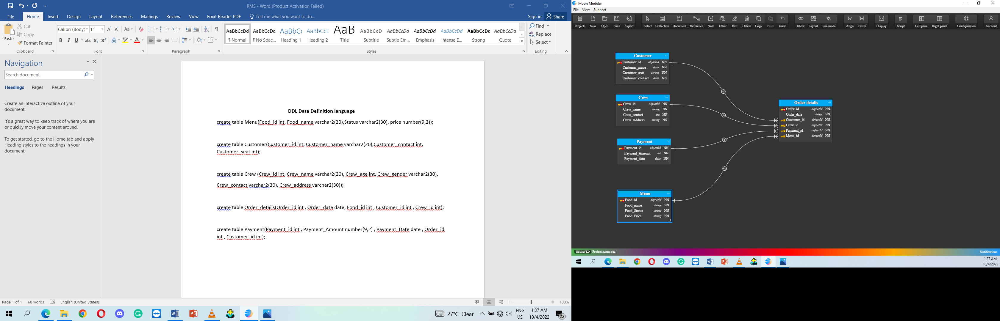

**DDL Data Definition language**

**create table accounts(User_name varchar2(30) , user_password varchar2(20),user_type varchar2(30));**

insert into accounts(user_name, user_password,user_type)

values('Sabir','Sabirwadho','manager');

create table user_acc(user_id varchar2(50),user_password varchar2(50),user_type varchar2(50));

insert into user_acc(user_id,user_password,user_type)

values('sabir ','wadho','manager')

values('sami','samiwadho','employees')

create table Customer(Customer_id int, Customer_name varchar2(20), Customer_seats varchar2(20),Customer_Contact int,constraint Customer_id_pk primary key(Customer_id));

create table Crew(Crew_id int, Crew_name varchar2(20), Crew_Contact int, Crew_Address varchar2(50),constraint Crew_id_pk primary key(Crew_id));

create table Payment(Payment_id int, Payment_Amount varchar2(20),Payment_Date date ,constraint payment_id_pk primary key(payment_id));

create table Menu (Food_id int , Food_name varchar2(20), Food_Status varchar2(20),Food_Price number(9,2),constraint food_id_pk primary key(food_id));

create table Order_Details(Order_id int, Order_date date,Customer_id int,Crew_id int ,Payment_id int, food_id int ,constraint order_id_pk primary key(order_id),

CONSTRAINT Order_Details_customer_fk FOREIGN KEY (customer_id) REFERENCES customer(customer_id),

CONSTRAINT Order_Details_crew_fk FOREIGN KEY (crew_id) REFERENCES crew(crew_id),

CONSTRAINT Order_Details_payment_fk FOREIGN KEY (payment_id) REFERENCES payment(payment_id),

CONSTRAINT Order_Details_menu_fk FOREIGN KEY (Food_id) REFERENCES menu(Food_id));

insert into Customer(Customer_id ,Customer_name,Customer_seats,Customer_Contact )

values(1001,'Abdul Ahad','15',03101333111);

values(1002,'Abdullah','11',03123456432);

values(1003,'Abdul Sami','13',03336454364);

values(1004,'Abdul Samed','12',03455643341);

values(1005,'Safder ','10',03465444446);

insert into Crew(Crew_id, Crew_name ,Crew_Contact, Crew_Address)

values(1902211,'Usama Ali',03231333313,'112 house block 13 johar karachi');

values(1902212,'Sajjad Ali',03231232113,' 192 house block 13 johar karachi');

values(1902213,'Sabir Ali',03400024444,' 321 house block 11 johar karachi');

values(1902214,'Sadique Ali',03333223221,' 311 house block 12 johar karachi');

values(1902215,'Imran Ali',03133321111,' 133 house block 11 johar karachi');

insert into payment(payment_id, payment_Amount, payment_date)

values(0231131,'PKR 1000',to_date('2020/07/15:11:59:10PM','yyyy/mm/dd:hh:mi:ssam'));

values(0231132,'PKR 2400',to_date('2020/07/15:12:12: 11PM','yyyy/mm/dd:hh:mi:ssam'));

values(0231133,'PKR 2200',to_date('2020/07/15:12:15: 11PM','yyyy/mm/dd:hh:mi:ssam'));

values(0231134,'PKR 4300',to_date('2020/07/15:12:30: 11PM','yyyy/mm/dd:hh:mi:ssam'));

values(0231135,'PKR 3200',to_date('2020/07/15:12:31: 12PM','yyyy/mm/dd:hh:mi:ssam'));

insert into menu(Food_id , Food_name, Food_Status , Food_price)

values(12001,'Nihari','preferred ', 1000);

values(12002,'Kabuli Pulao mandi','recommend ',2400)

values(12003,'Mutton Komra','special ',2200)

values(12004,'Paya',' special ',4300)

values(12005,'chapli kebab',' regular',3200)

insert into Order_Details(Order_id , Order_date ,Customer_id ,Crew_id ,Payment_id , food_id)

values(101,to_date('2020/07/15:11:59:10PM','yyyy/mm/dd:hh:mi:ssam'), 1001,1902211,0231131,12001);

values(102,to_date('2020/07/15:12:12:11PM','yyyy/mm/dd:hh:mi:ssam'), 1002,1902212,0231132,12002);

values(103,to_date('2020/07/15:12:15:11PM','yyyy/mm/dd:hh:mi:ssam'), 1003,1902213,0231133,12003);

values(104,to_date('2020/07/15:12:30:11PM','yyyy/mm/dd:hh:mi:ssam'), 1004,1902214,0231134,12004);

values(105,to_date('2020/07/15:12:31:12PM','yyyy/mm/dd:hh:mi:ssam'), 1005,1902215,0231135,12005);

declare

a varchar2(50);

b varchar2(50);

c varchar(50);

begin

select user_id,user_password,user_type

into a,b,c

from user_acc

where user_id=:PUT_USER and user_type=:user_type;

if :user_type='manager' then

if a=:PUT_USER then

if b=:PUT_PASSWORD then

GO_BLOCK('HOME');

show_view('HOME');

HIDE_VIEW('LOGIN');

else

message('Incorrect password');

end if;

else

message('Incorrect username');

end if;

else :user_type:='employees';

if a=:PUT_USER then

if b=:PUT_PASSWORD then

open_form('C:\PROJECT\final\CREW.fmb');

GO_BLOCK('HOME_PAGE');-----GO THAT BLOCK WHICH WE WANT

SHOW_VIEW('HOME_PAGE');----SHOW THAT CANVIX WHICH BLOCK IS

HIDE_VIEW('LOGIN');

else

message('Incorrect password');

end if;

else

message('Incorrect username');

end if;

end if;

END;